Q1

(a)

When the value y is outlier, compared to Squared Error Loss, the Huber loss is much less which is shown in below plot. ($δ=333, y^{'}s interval is [-999,999]$)

(b)

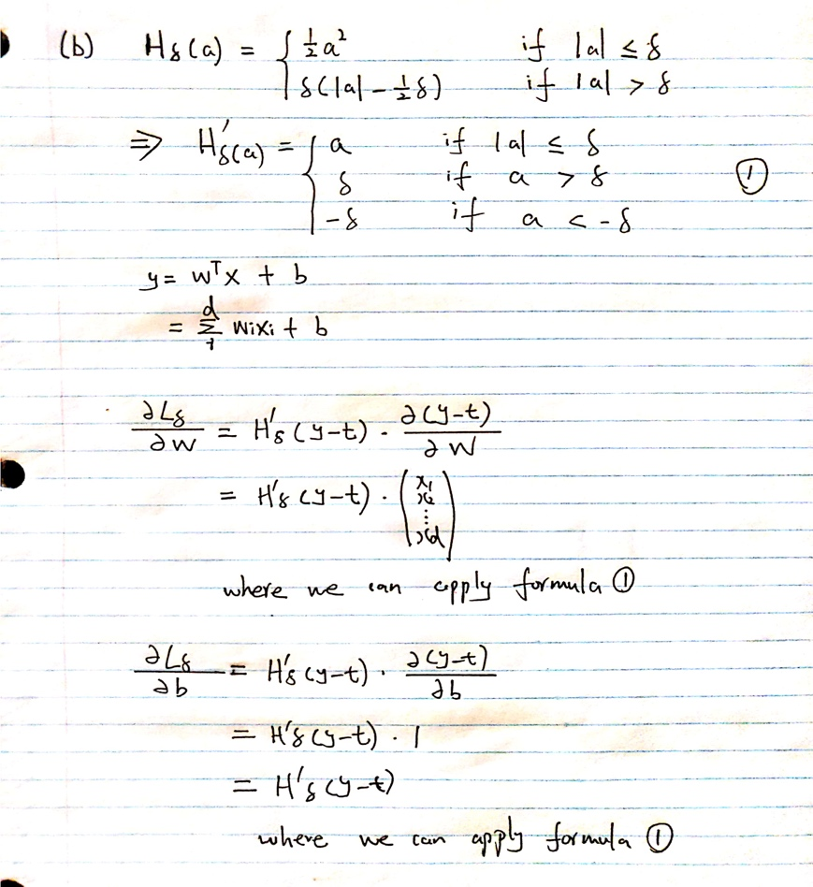

Q2

(a)

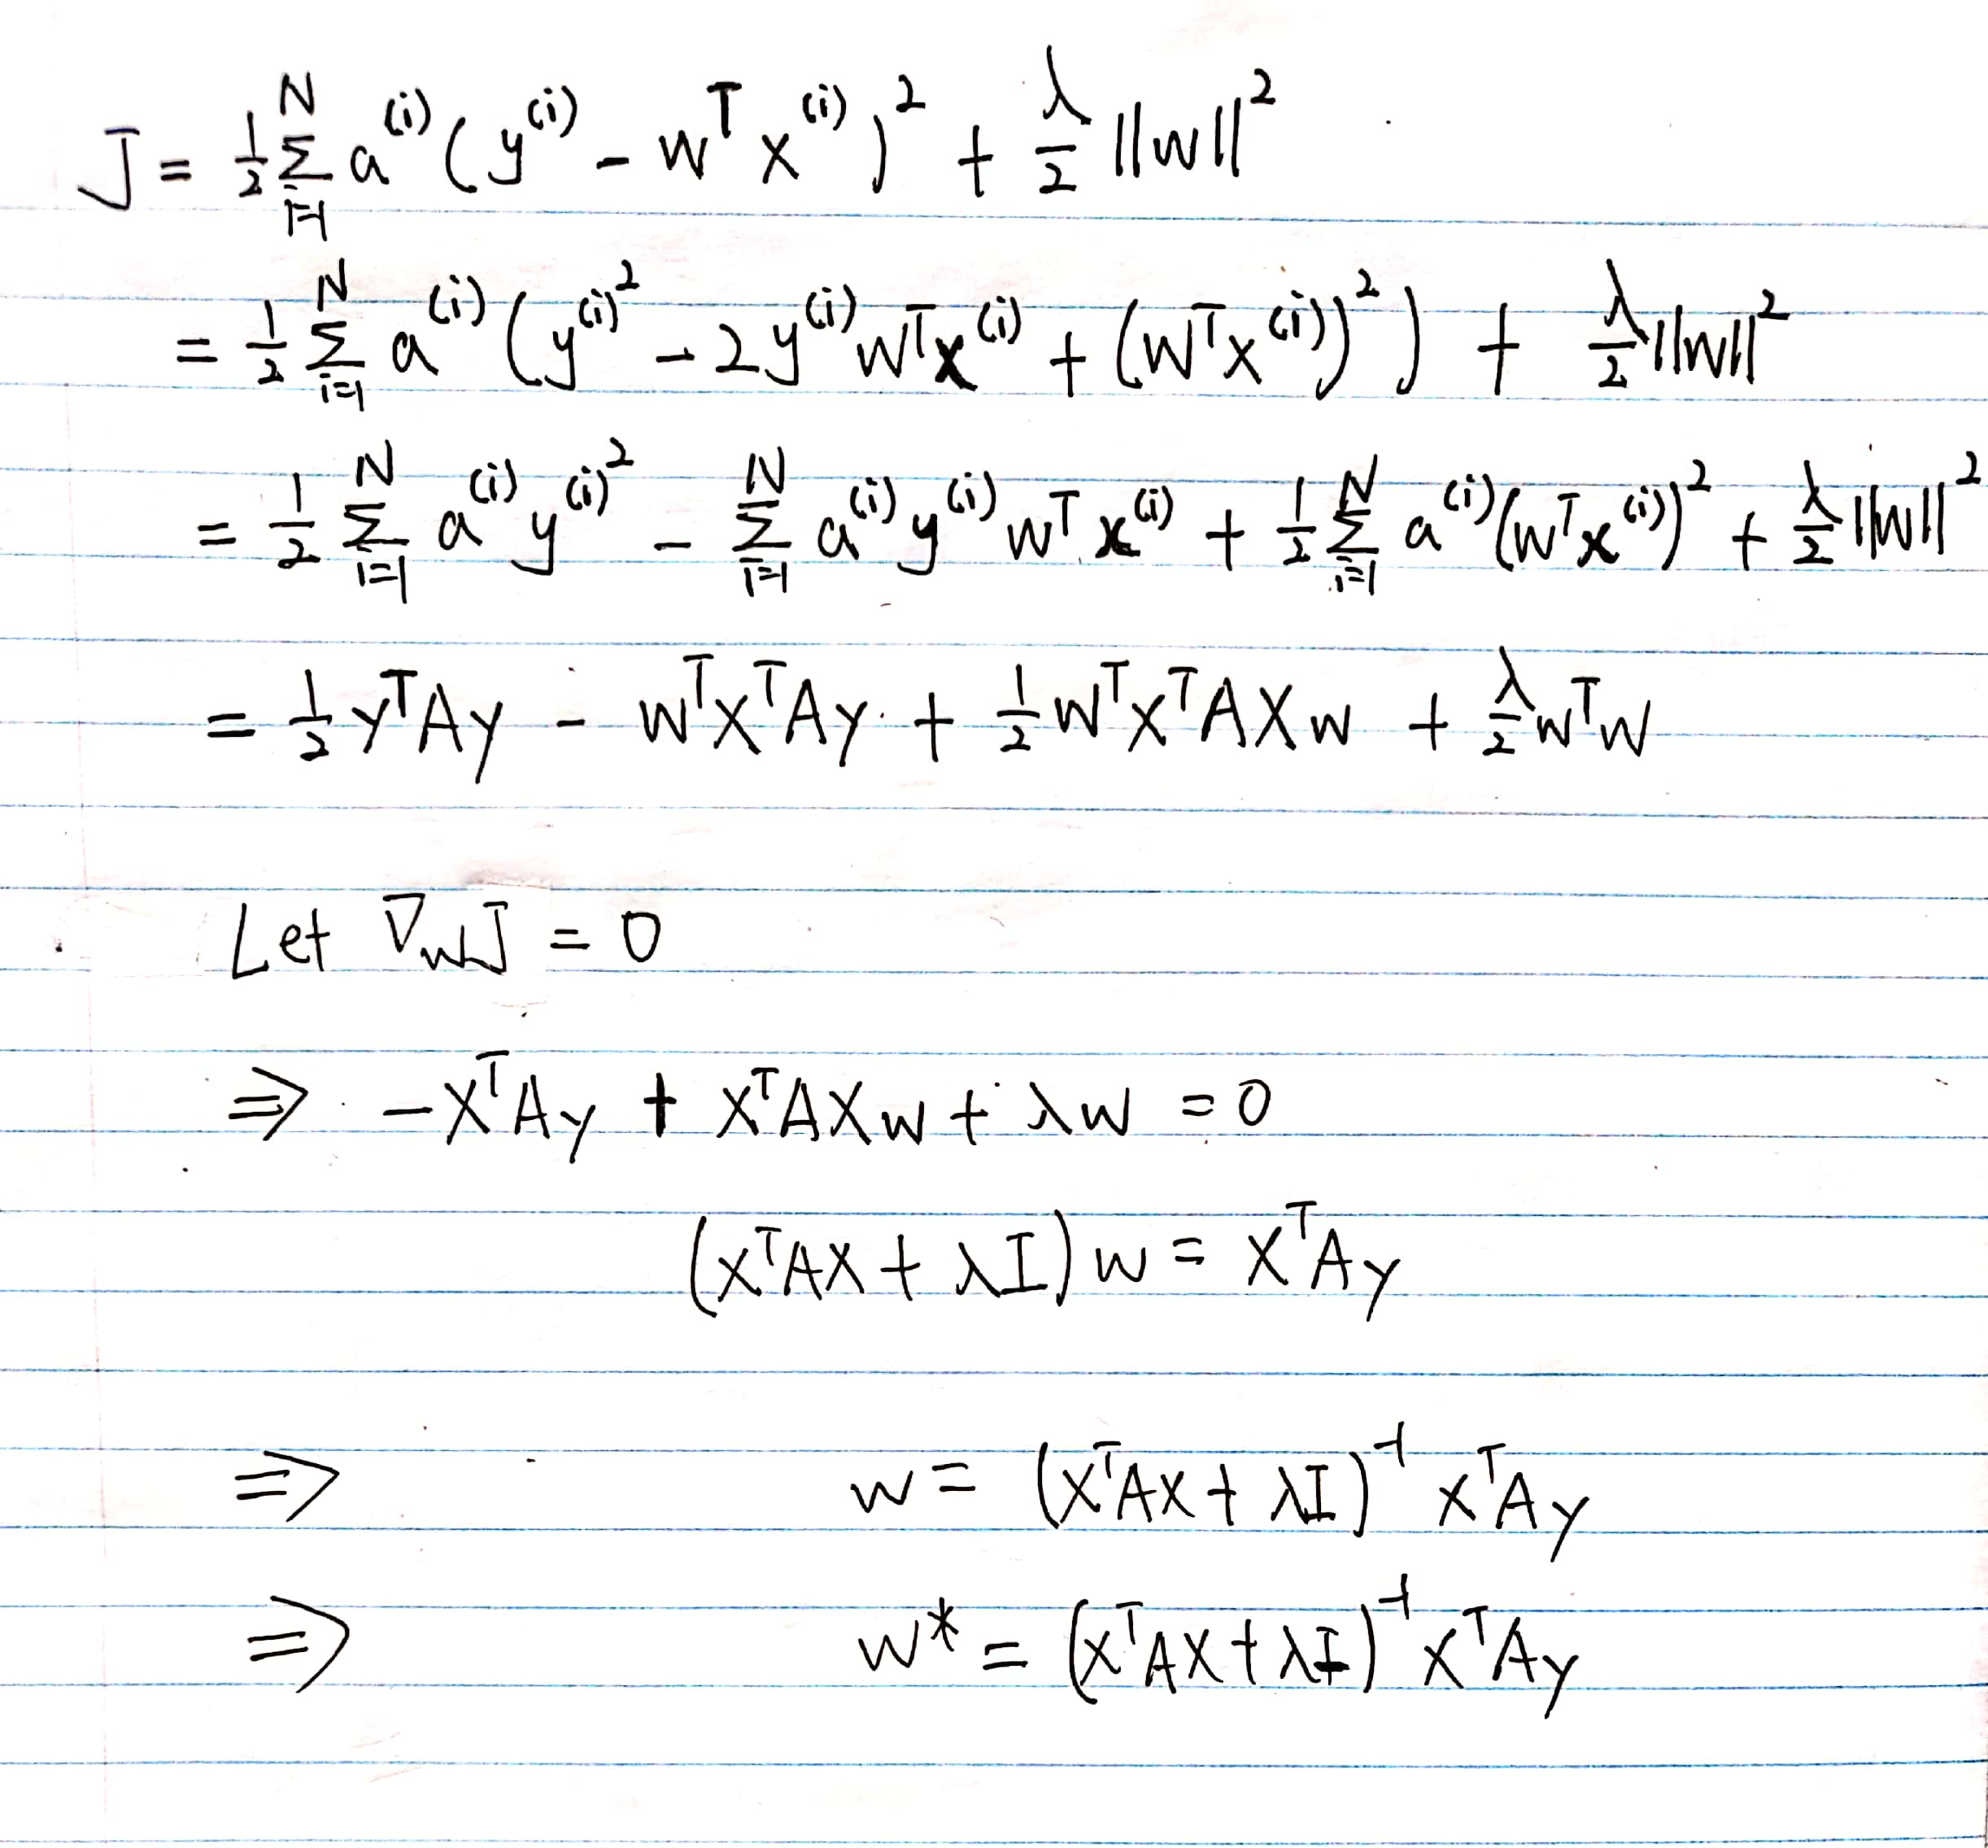

(c)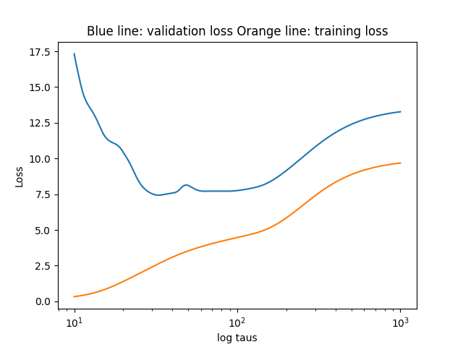

(d)

When $γ$-> $∞$, each training example is equally weighted, so the model is close to standard regression with L2 penalty.

When $γ$-> $0$, the test point becomes dramatic driver to the model which could lead poor generalization.